NU606-ASSIGNMENT-DERMATOLOGY
Each response must have a reference, including at least two scholarly references other than your textbook or course materials.
Your answers should comprehensively address the questions posed. You may use the same reference more than once if appropriate.

You are performing an annual physical exam on Mrs. Whyte, a 56 y.o caucasian woman. During your exam of her shoulder, you notice a suspicious looking skin growth on her back. Mrs. Whyte states that it has been there a long time but does seem to be getting bigger. She reports that it occasionally bleeds and now seems to be darker than it was before.

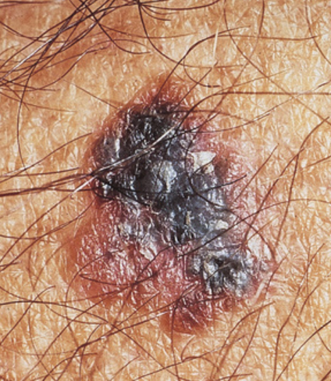

- What additional questions would you ask her? What are some risk factors for skin cancer?

- List the signs of possible malignant changes in a skin lesion. Which of these signs is Mrs. Whyte exhibiting?

- Based on the description and appearance, which type of lesion are you most suspicious for? In your answer discuss the characteristics of the typical lesion of squamous cell carcinoma, melanoma, and Kaposi sarcoma.

- List the four warning signs of skin cancer. Which of these is Mrs. Whyte exhibiting?

- Assuming there were no concerning lesions noted during your exam what would you recommend for preventative care of the integumentary system?

