DEVELOPING A MOBILE APP FOR A CAR-SHARING COMPANY

Developing a mobile app for a car-sharing company

# Introduction

## Project Idea

The project focuses on designing a mobile application that will be used in a car-sharing Company XYZ. This project will be a practical task involving the execution of software development activities involving requirements collection and analysis, design and development, implementation, and maintenance.

## Justification

Mobile smartphone applications' utilisation offers better performance and new possibilities, and the critical functional features such as getting feedback are readily available and accessible (Ahmadzadegan et al., 2020). The car-sharing business model is rapidly growing with the adoption of technologies such as mobile applications and websites that automate customer relationships and provide a simple, easy-to-use user interface that supports self-service (Perboli et al., 2018). Unlike websites, mobile applications do not require third party software since they are easily installed in the smartphone and avail all the functions. Therefore, the development of a mobile application for Company XYZ (that use websites for its service) will be a significant milestone towards improving its business model and customer experience. The company itself, managers, and customers will benefit from the new app. Besides, this project's specific purpose is to address the current challenges of poor user experience and incompatibility of the website used by Company XYZ and introduce an innovative solution.

## Background of the Topic

Company XYZ has been using a website to manage and offer customer services for its car-sharing business. However, the customers face challenges such as inability to navigate through all the features (as the website is non-responsive), poor user experience since some browsers do not effectively render all the functional components. These challenges limit the company's competitiveness, especially in the modern market where the car-sharing business model is evolving and widely adopted, and digital technologies embraced operator groups and customers (Remane et al., 2016). Mobile applications are considered the most innovative solutions because they are easily accessible by all stakeholders (such as the customers, car sharing company employees, and the managers) using smartphones. Company XYZ hopes to increase its customer base, provide more interactive features to enable customers to access and rent cars quickly, and acquire an efficient management system for its car-sharing business. This project is interest to me because it entails the implementation of an innovative solution that can be adopted or purchased by a car sharing or renting company. I hope to gain experience in mobile application design and development skills vital for professional growth in software development.

# Scope, Aim, and Objectives

## The Overall Intention of the Project

The project's overall intention is to create a mobile app that can be used by Company XYZ to rent cars or vehicles and manage its car-sharing business. The following are the aims and objectives of the project.

Aim1: To develop a mobile app for Company XYZ

Objective 1.1: To design, program, and test the mobile application for Company XYZ.

Objective 1.2: To design an interactive user interface of a mobile app suitable for car-sharing business.

Objective 1.3: To design a database of a car sharing mobile application.

Aim2: To convert the car-sharing functions implemented in the current website into a mobile app.

Objective 2.1: To analyse all the functional and non-functional requirements for the mobile app.

Objective 2.2: To collect feedback about the user experience of the car-sharing company's current technology.

Objective 2.3: To modify the previous car sharing functions to fit in a new technology and meet customer demands.

Aim3: To improve the performance and service delivery of Company XYZ

Objective 3.1: To implement crucial and reliable features for the business

Objective 3.2: To provide a guide for troubleshooting common errors in the new application.

Objective 3.3. To train employees and customers of the company on how to use the newly adopted system.

## Deliverables

By the end of this project, the following will be the outcomes.

1. A mobile application – this will be a software that can be installed in a smartphone device and test the functional features of car sharing. This outcome will also include the program codes, executables, and supporting files.
2. User manual – a document that will be utilised by the company to train its employees on how to execute the functional and non-functional requirement features.

# Methodology

## Project approach

This project will employ a problem area-based approach to address an existing challenge of lack of a reliable and innovative solution for Company XYZ. Rather than considering all the business activities in the company, this project mainly focuses on creating an IT solution to promote the business model for Company XYZ as it strives to compete in the market.

## Methodology Followed

Agile, incremental software development methodology will be followed in this project. Agile methodology is appropriate for this project because it offers flexibility and adaptability to accommodate new requirements and enables the developer to deliver some functional parts and obtain feedback to improve before releasing the final product (Abrahamsson et al., 2017). The activities to be undertaken include; requirements collection and analysis, modelling the system, database design, coding of the functional components and unit, component, and overall system testing. These activities are crucial for ensuring that the standard software development lifecycle is followed and the client’s requirements are accommodated in the final product. Moreover, the methodology's functional boundaries include; inability to determine when customers may change the requirements and always accommodating new changes.

## Constraints

The following restrictions define the project’s limitations; first, the client’s understanding of the overall idea – the client is the sponsor of the mobile app being developed. Hence, the failure of understanding of the idea could limit the capabilities of identifying the key software requirements. Second, funding resources will be required to gather essential tools and systems to design, develop, and test the system. Third, the client must not suggest new changes at the deployment stage of the project, as the suggestions may lead to delay of the entire project. Fourth, the application may not be used to store and manage all the company information resources covering every department. Besides, the aims and objectives above define the boundaries of activities performed in the project.

## Assumptions

It is assumed that:

1. The final software product meets that functional and non-functional requirement. The requirements are used as the basis of assessing the success of the project, and the final product must ensure all requirements specified by the client are met, failure to which the project may be declared as failed.
2. The mobile app is adequately tested from the unit stages. Testing is essential to avoid future errors and potential vulnerabilities to cyber-attacks.
3. The project sponsor provides adequate funding. Lack of sufficient funds is a major risk that may hinder the project's completion or cause a delay.
4. The feedback is obtained early before launching the final application. The feedback should be provided at the early stages for the developer to make adjustments before releasing the final mobile app.

## Contingency Plans

In case things go wrong during the project implementation, the potential alternative ways that can be adopted: backup and retrieve the program codes and restart the project from where the risk occurred. A copy of the mobile app codes will be stored in a secured flash drive to help recover completed parts in case of loss of a laptop or compute used to code the app or loss of the actual program files. Alternatively, another application readily available from other vendors can be used and customised to meet Company XYZ’s requirements if the delivered product is not accepted.

# Project Plan

## Major Milestones

1. Kick-off meeting
2. The mobile app software requirements analysis
3. Application design documentation
4. Application design and testing cases
5. Final mobile application release.

## Resource List

1. Laptop – hosts the operating system that supporting the development, design, and testing tools.
2. Java IDE – to support java development features used by the Android development kit.
3. Android development kit – used to code and test the mobile app.
4. Smartphone – used to test the final software product.

## Skills

The available skills include; Java programming, database design, modelling, IDE installation and configuration, and Android programming. Besides, the required skills are; testing of all the use cases and project management.

## Risks

The potential risks that might compromise the success of the project include:- lack of adequate funding, non-availability of coding and development resources, lack of access to the client or poor communication with the client, and other commitments with coursework.

## Work Breakdown Structure

Figure 1 below presents all the tasks that must be undertaken and completed in this project.



Figure 1: Work breakdown structure (Author, 2020)

## Gantt Chart

The project will be implemented within three months, as shown in figure 2 below.

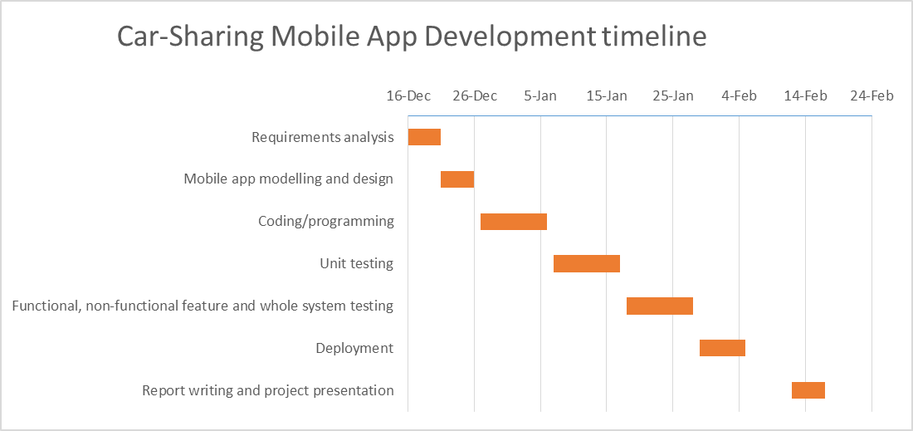

Figure 2: Gantt chart (Author, 2020)

# Literature Review

## Introduction

The car-sharing mobile app is a crucial innovation that can improve the company's performance and the customer’s experiences with car renting services (Ahmadzadegan et al., 2020). The app's design and development must incorporate functional features useful for company management, employees, and customers. Car-sharing services have rapidly grown in the recent past, and they are considered the most sustainable transportation means (Ferrero et al., 2018). This project is important as it focuses on introducing an innovative digital solution that could enhance the company's capabilities and customer interaction and efficient management of rented cars. Within the literature, this project appropriately fits in innovation and technology advances in the car-sharing business model that is currently widely accepted across the globe. This section presents a critical review of previous literature on car sharing systems or technologies and business models.

## Car Sharing Technologies

The most commonly used technologies for car-sharing are websites and mobile applications (Perboli et al., 2018). Ferrero et al. (2018) argued that mobile apps are used in locking and unlocking cars. In this case, the mobile apps are used explicitly for the shared vehicles' functional management and operation. On the other hand, Perboli et al. (2018) argued that mobile apps are implemented in car-sharing companies to support customers' self-service. Additionally, the mobile apps are utilised in engaging the customer case assistants at the call centre to resolve issues encountered while operating the vehicles. The customers can use the applications to pay the rental fees and other related expenditures. Furthermore, unlike the claims of Perboli et al. (2018) and Ferrero et al. (2018), Shaheen et al. (2015)’s claims indicated that mobile applications are used by providing keyless access to the cars, tracking and monitoring the location of vehicles through by taking advantage of the global positioning system. Therefore, mobile apps are adopted and used in car-sharing companies due to multiple reasons and unique purposes, depending on the organisational requirements.

Kopp, Gerike, and Axhausen (2015) noted that the mobile app is useful in extracting and transmitting positional data, thus supporting Shaheen et al.'s (2015) findings. The sensor information can be used to determine the vehicle's acceleration and remotely engage the operator to ensure that the car is used efficiently and safely. On the other hand, websites are utilised to store information about car-sharing companies and interact with potential customers to gather feedback and recruit renters (Bocken et al., 2020). Hence, even the websites offer a platform for company interaction with customers and employees, thus ensuring that all parties are engaged and accommodated. However, the websites may fail to store all sensitive information, such as emails sent by the organisational representatives (Bocken et al., 2020). Consequently, the websites are unreliable than mobile apps in managing car-sharing services in a company.

## Car Sharing Business Model

The car-sharing business models significantly differ in terms of the behaviour of those not using car-sharing technologies (Kopp et al., 2015). According to Bocken et al. (2020), the car-sharing business model has evolved and is being accepted in the transport industry in major cities such as the Swedish cities. Similarly, argue that the emergence of digital solutions and platforms such as Cuitymapper, Uber, and Mobike have significantly played a major role in developing and developing the car-sharing business model (Acquier, Carbone, and Masse, 2019). Most of the platforms are implemented as smart mobile applications that are easy to access and use and utilise intelligent features to provide information about congestion in the cities, thus enabling them to avoid traffic jams (Acquier, Carbone and Masse, 2019). Therefore, innovation and implementation of digital solutions are crucial for the business model’s growth.

## Ethical and Social Aspects and Implications

The majority of the youths are getting driving licenses every year, but most of them prioritise mobile application technologies over cars. As the concept of car sharing is widely accepted, there is a significant reduction in the challenges of lack of urban parking spaces and traffic jams. The number of cars driven in the cities, greenhouse gas emissions, and the local population's transport costs will significantly reduce. The stakeholders focus on creating social, environmental, and economic value (Acquier, Carbone, and Masse, 2019). These ethical and social aspects imply that car-sharing technologies positively impact society, urban socioeconomic development, and the sharing economy's emergency. Moreover, the changes in preferences of access over ownership and peer-to-peer car-sharing have greatly transformed most sectors.

# References

Abrahamsson, P., Salo, O., Ronkainen, J. and Warsta, J., 2017. Agile software development methods: review and analysis. *arXiv preprint arXiv:1709.08439*.

Acquier, A., Carbone, V. and Massé, D., 2019. How to create value (s) in the sharing economy: business models, scalability, and sustainability. *Technology Innovation Management Review*, **9**(2).

Ahmadzadegan, M.H., Izadyar, M., Deilami, H.A. and Ghorbani, H., 2020, July. Detailed study on the features of mobile applications. In *2020 International Conference on Electronics and Sustainable Communication Systems (ICESC)* (pp. 901-907). IEEE.

Bocken, N., Jonca, A., Södergren, K. and Palm, J., 2020. Emergence of carsharing business models and sustainability impacts in Swedish cities. *Sustainability*, **12**(4), p.1594.

Ferrero, F., Perboli, G., Rosano, M. and Vesco, A., 2018. Car-sharing services: an annotated review. *Sustainable Cities and Society*, **37**, pp.501-518.

Kopp, J., Gerike, R. and Axhausen, K.W., 2015. Do sharing people behave differently? An empirical evaluation of the distinctive mobility patterns of free-floating car-sharing members. *Transportation*, **42**(3), pp.449-469.

Perboli, G., Ferrero, F., Musso, S. and Vesco, A., 2018. Business models and tariff simulation in car-sharing services. *Transportation Research Part A: Policy and Practice*, **115**, pp.32-48.

Remane, G., Nickerson, R., Hanelt, A., Tesch, J.F. and Kolbe, L.M., 2016. A taxonomy of carsharing business models.

Shaheen, S.A., Chan, N.D. and Micheaux, H., 2015. One-way carsharing’s evolution and operator perspectives from the Americas. *Transportation*, **42**(3), pp.519-536.