Coursework Cognitive Psychology 2020-2021

In week 19, a PsychoPy script, trial files and stimuli will be posted on blackboard in the assessment folder. Download all the files. Your task will be to run the experiment on yourself, calculate your mean response times for each condition, and write a 2000 words report about the experiment. The report is due by noon on Monday 22nd March 2021.

Using the PsychoPy script to find the relevant information, your report will include a short abstract (150-200 words), introduction of the topic (600 words) the methodology of the task (600 words to include design, material and procedure) a result section (200 words including data collation) and discussion (400 words) with references (not included in the word count). Word counts for each section are suggested only.

In appendix, you will have to include a screen shot of the original data file showing your p-number and date-stamp (see Figure 1), and a final screen shot showing your calculated means (see Figure 2).

The following skills will be assessed in this assignment:
1. Downloading and saving PsychoPy script, trial files and stimuli
2. Running an experiment in PsychoPy
3. Keeping original (raw) data file untouched
4. Calculating the means for each condition (which could include additional steps, for example, sorting, removing incorrect trials, using sub-total function, etc) in each block.
5. Saving edited data file under a new name
6. Finding a range of methodological details from a PsychoPy script (procedure, number of trials, type of trials, response buttons, feedback, practice trials, etc)
7. Writing a concise but complete report with references.

We will be marking your coursework using the following marking rubric:

Abstract 5%
States aims, what was done, what was found and interpretation of findings clearly and concisely.

Introduction 15%
Introduces the research topic clearly and concisely. Includes a good range of relevant sources. Demonstrate a clear understanding of the topic. Includes an excellent rationale for the study and states hypothesis very well.

Method 30%
10% for design: Clearly and concisely explains the design of the experiment with independent and dependant variables.
10% for materials: Clearly and concisely explains the material used in the study with examples.
10% for procedure: Explains in detail the procedure for the experiment. Provides enough information to allow for a replication of the study.

Results 10%
Explains how the results were arrived at (what steps were taken in excel) with references to the appropriate screen shots in Appendices. Clearly states the results for each condition (means and standard deviations) in each block.

Discussion 15 %
Summarises the aim of the experiment and the results. Explains what would need to be done to be able to conclude anything from the experiment. Explains the implications of the findings if similar results were found in a bigger sample. Links this study to relevant theories and/or previous studies. Suggest changes to the experiment to improve or alter this study in the future.

References 5%
Entirely appropriate standard of references in text and reference list is complete and correctly formatted.

Appendices 20%
10% Screen shot of the raw data file showing your p-number, the date stamp and the file name.
10% Screen shot of the edited data file showing your p-number, your final means for each condition in each block as well as the new file name.

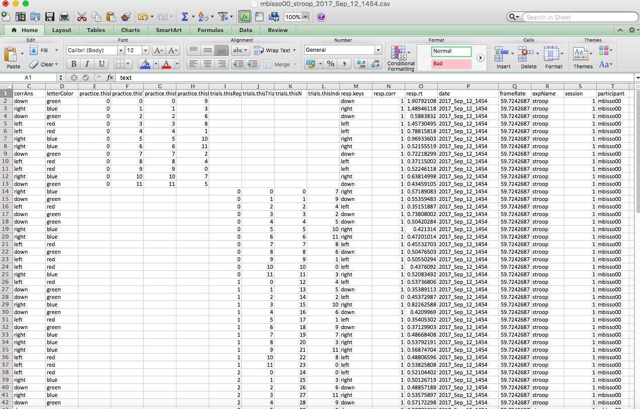
Figure 1: Example screen shot showing the original data file. Note how my p-number (mbisso00) and the date I conducted the experiment on myself (2017_Sep_12_1454) are clearly visible in the data file. In addition, the original file name is clearly displayed at the top of the screen.

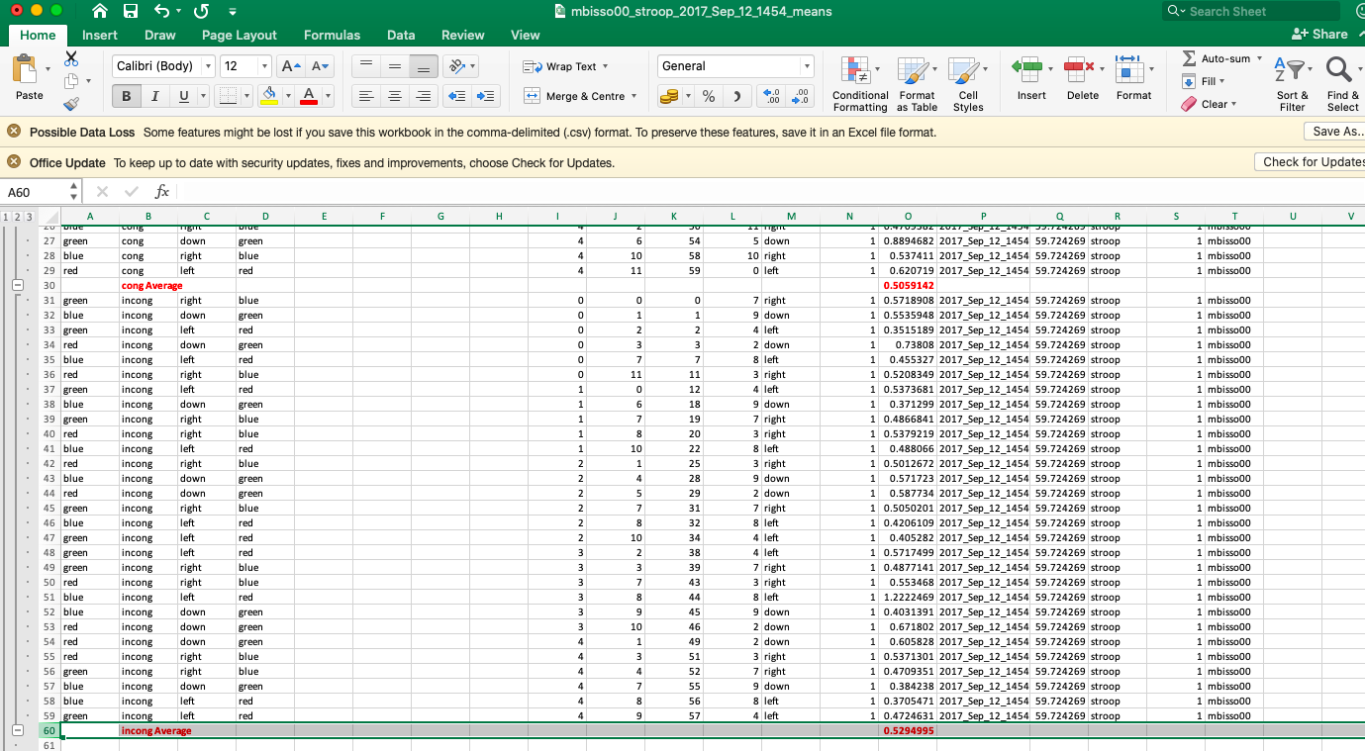
Figure 2: Example screen shot showing mean response times for each condition. In this example, there was only one block. Note that my participant number is still clearly shown “mbisso00” in the last column and we can see the date stamp in the datafile. In addition, the file name has been changed and is clearly displayed at the top of the screen to reflect that this is the edited data file.

