**EXPERIMENT 3 = Purification of cholesterol**

Background

In this experiment, you will perform a bromination, followed by a reductive elimination reaction, in order to purify a sample of crude cholesterol.

Cholesterol is a steroidal compound present in animal cells. It is a structural component in cell walls and is also required for the formation of the myelin sheath covering nerve bundles and is a precursor for other important steroidal hormones.

Cholesterol isolated from natural sources is generally contaminated with ~3‐5% of related compounds.

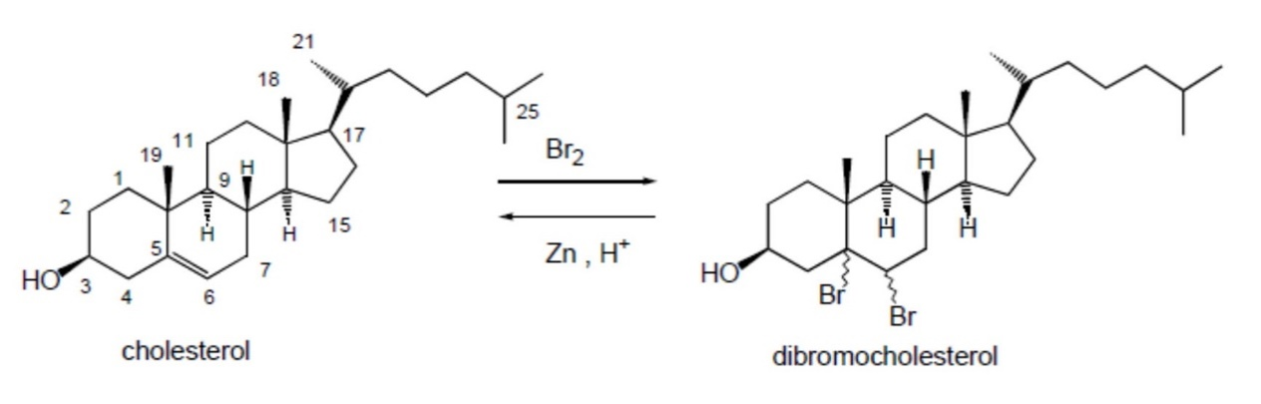

**Bromination**

Weigh out 1g of cholesterol into a 100mL conical flask and dissolve it in 7mL of *t*‐ butyl methyl ether. Place on a steam bath in the fume cupboard until fully dissolved. Remove from the heat and add dropwise a solution of bromine in acetic acid containing sodium acetate (**5 ml**, composition: 9% w/v bromine in acetic acid with 0.8 g sodium acetate, already prepared) using a graduated glass pipette.

Once the reaction has stopped, stir the reaction mixture with a glass rod and allow it to cool over an ice bath for 5 minutes in the fume hood. In a 100mL beaker, prepare a solution of ether (3 ml) and acetic acid (7 ml) and allow it to cool in an ice bath. Dilute the reaction mixture with a few drops of cold ether/acetic acid and collect the precipitate, cholesterol dibromide by suction filtration. Carefully wash the solid material with the cold ether/acetic acid mixture to remove traces of bromine. Wash the solid with cold methanol. Continue to apply suction until the solid is reasonably dry, then transfer it to a pre‐weighed 100 ml conical flask.

Record the yield of the reaction and set a sample aside (5 to 10 mg) for melting point determination and TLC analysis.

**Reductive elimination**

To the 100mL conical flask containing your product from the previous step, add 20mL of *t*‐butyl methyl ether. To this mixture add acetic acid (5 ml) and zinc dust (0.2g) and swirl for 5‐10 minutes. Add water dropwise to dissolve all solids formed, apart from zinc dust.

Decant the solution (leaving all zinc dust behind) into a separating funnel and wash twice with water using 10 ml each time. Then wash once with 10mL of 10% sodium hydroxide and finally wash once with 20 ml saturated sodium chloride Collect the organic layer in a 100 ml conical flask and dry with anhydrous sodium sulphate. Filter over filter paper the organic layer into a 100 ml conical flask, add about 10 ml of methanol and a couple of anti‐bumping granules. Evaporate the solution on a steam bath to the point where the cholesterol begins to crystallise. Remove from the heat and cool over an ice bath. Collect the product by suction filtration and wash with a few drops of cold methanol. Dry in a 70oC oven for 10 minutes.

Record the yield and % yield for each reaction.

Determine the melting point of the starting cholesterol and of the dry, recrystallised product.

**TLC analysis**

Perform TLC analysis on crude cholesterol, cholesterol dibromide and purified cholesterol. Dissolve separately an aliquot of crude cholesterol, cholesterol dibromide and purified cholesterol in a small volume of dichloromethane. Use the chromatography eluent (5% methanol in dichloromethane) provided in the fume hood. Transfer roughly 3‐5 mL into a TLC tank. Draw in pencil the baseline on the TLC plate. Once your TLC plate has been spotted with your analytes, gently place it into the tank ensuring the level of eluent in the TLC tank is below the baseline. Replace the lid and do not move the tank until the eluent has reached roughly 10 mm from the top of the plate. Allow to dry and then spray the TLC plate with the stain provided (phosphomolybdic acid stain) in the fume hood. Draw a diagram of your TLC plate with the best separation in your lab book:

**FTIR ANALYSIS**

You have been provided with FTIR spectra of the crude cholesterol, dibromocholesterol and purified cholesterol. Using the FTIR interpretation guide, identify the functional groups with band numbers of each of the compounds