Literature Research Project
Estimating Air pollution and its relationship with Human Health

Data
The number of deaths attributed to outdoor ozone and particulate matter pollution per 100,000
Similar population
China: 60.5 deaths per 100,000
India: 88 deaths per 100,000

Similar deaths rate per 100,000
UK: 17.8 deaths per 100,000
Columbia: 17.9 deaths per 100,000
Italy: 16.9 deaths per 100,000
Madagascar: 18.4 deaths per 100,000

Comparing cities. Similar population vs similar size of city
London: 9M population – 1572Km²
New York: 8M population – 783.8 Km²
Hyderabad: 10M population – 625 Km²
Hong Kong: 7.5M population – 1106 Km²
Vs
London – 9M Population – 1572 Km²
Huston – 6.1M population – 1553 Km²
São Paulo – 21.6M population – 1521 Km²
Dheli – 28.5M population – 1484 Km²
- Use these counties and cities to show the impact to human health and give examples

https://ourworldindata.org/outdoor-air-pollution (Main website used for the data)
Estimating Air pollution and its relationship with Human Health

Introduction
Air polution is defined as a mixture of solid and gaseous particles into the air which has harmful or poisonous effects. Air poluition has been an area of growing importance in the last few decades, the response from the public and world leaders has been good and efforts have been made to decrease air polution. However decreasing air polution is not as simple as it sounds, the main causes of air polution are combustion in the industry, vehicle emissions, aggraculture side effects, deforestation and many more. Air polution is also a big factor in human health, long and short term exposure to air suspended toxicants has different toxicological impacts on humans including respiratory and cardiovascular diseases, neuropsychiatric complications, skin diseases, and long-term chronic diseases such as cancer. The Lancet researched two important categories of air polution, “indoor (household) and outdoor (ambient). Household air pollution concerns people who mostly use solid fuels, such as coal, wood, or charcoal. 4·3 million people die annually from household air pollution, around 3·3 million of whom live in Asia. The major causes of these deaths are stroke, ischaemic heart disease, chronic and acute lung disease, and lung cancer. WHO estimates that 3·7 million people die annually from ambient air pollution, again most of whom (2·6 million) live in Asia. The ranking of causes of deaths remains broadly similar. Most of those at risk of ambient air pollution live in urban settings.” (The Lancet, 2016)
What is particulate matter and why is it important?
Particulate Matter is a mixture of solid and liquid particles that are suspended in the air. These are categorized into coarse, fine and ultrafine particles. Coarse particles have a diameter of 2.5 micrometres to 10 micrometres. Dust, spores and pollen are some examples. PM2.5 refers to particles that have diameter less than 2.5 micrometres and remain suspended for longer. (Fuzzi et al., 2015) Some particles are more dangerous than others. Particles such as dust, soot, dirt or smoke, are large or dark enough to be visible. But the most damaging particles are minuscule particles, known as PM10 and PM2.5. PM2.5 particles are invisible to the naked eye and small enough to pass through the lungs, into the bloodstream, and into your organs.

This literature review looks at the effect of air polution on health in different countries.

Data for air polution in countries with similar population China vs India
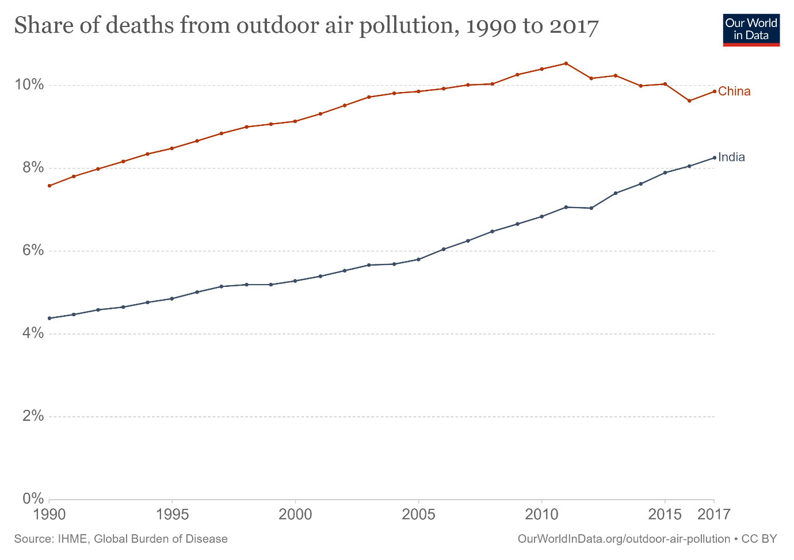
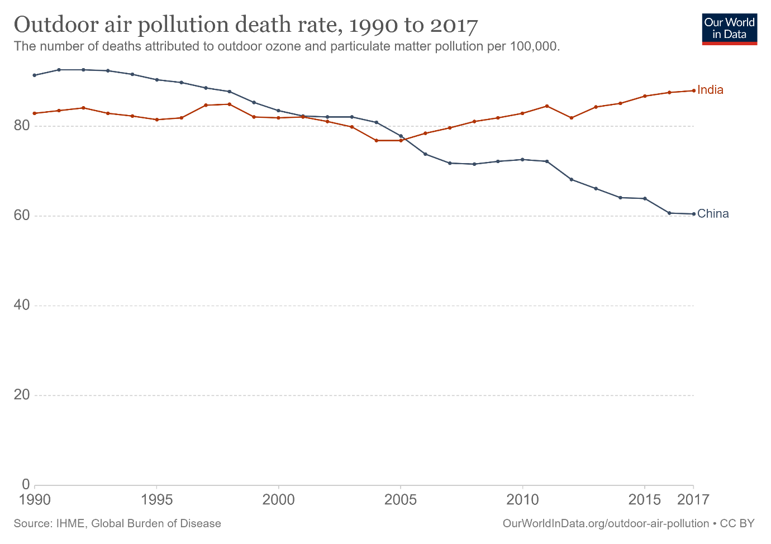
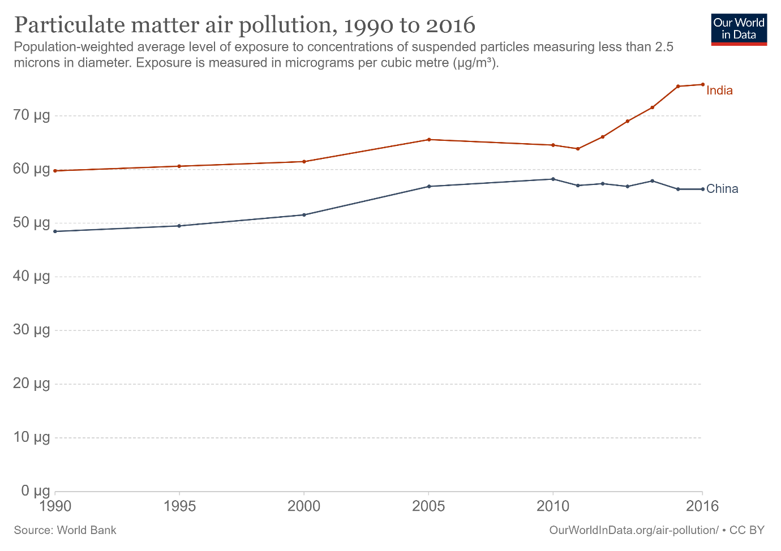
In the graph above (Figure 3) we see the distribution of the population-weighted mean exposure to PM2.5 each year.
Data for air polution in countries with similar death rate per 100,000
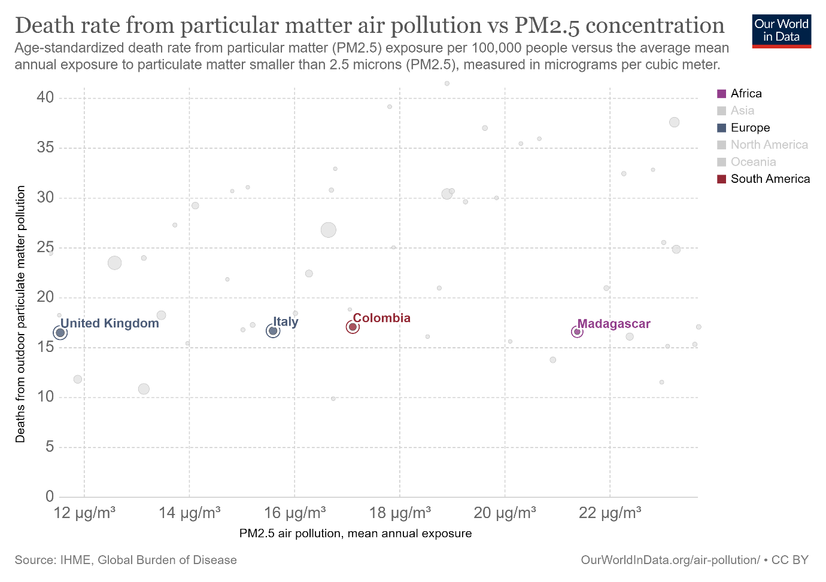
Data for air polution in cities with similar population

Data for air polution in cities with similar area size

Bibliography
- The Lancet, 2016. Air pollution: consequences and actions for the UK, and beyond. The Lancet, 387(10021), p.817.
- Fuzzi, S., Baltensperger, U., Carslaw, K., Decesari, S., Denier van der Gon, H., Facchini, M., Fowler, D., Koren, I., Langford, B., Lohmann, U., Nemitz, E., Pandis, S., Riipinen, I., Rudich, Y., Schaap, M., Slowik, J., Spracklen, D., Vignati, E., Wild, M., Williams, M. and Gilardoni, S., 2015. Particulate matter, air quality and climate: lessons learned and future needs. Atmospheric Chemistry and Physics, 15(14), pp.8217-8299.

