THEO 201: Theology and Culture Instructions
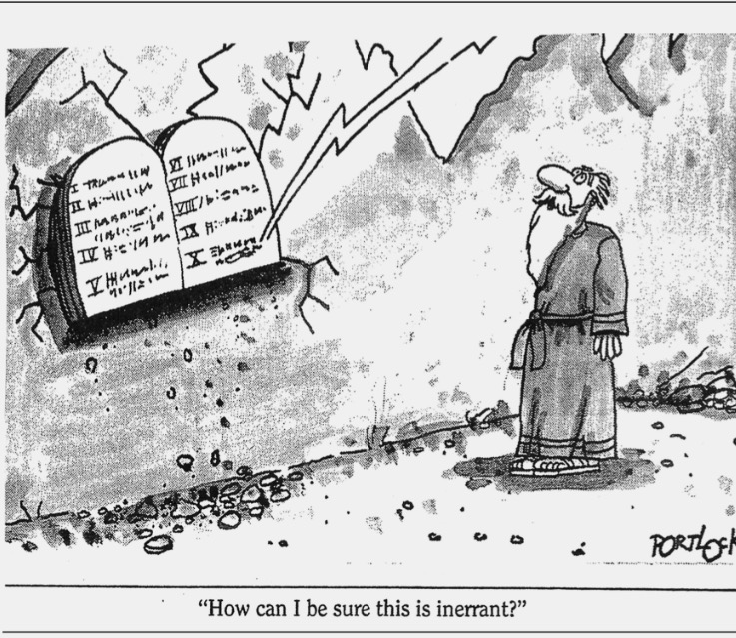

You must explain why Christians believe that the Bible is God’s word- inerrant and directly inspired. Then, in light of this belief, discuss how the Bible is still relevant today. Demonstrate this relevancy by discussing the Bible’s implications in modern society (ie. culturally, scientifically, morally, etc.) You must use the 1978 Chicago Statement on Inerrancy as a supporting source when discussing the doctrines, but you must also use two additional sources (one per section).

You must use the rubric and template provided exactly (if the template is not followed, points will be deducted) to ensure that your final submission has appropriate title headings, lists the word count, 1” margins, uses times New Roman 12 pt. font, double-spaced, and is 1000-1200 words (around 3-4 pages).

To clarify, your paper should discuss theology in culture in this way:

First, address biblical inspiration and inerrancy. This should include two things: (1) a definition and explanation of the doctrine, and (2) discussions of how both doctrines relate to each other. In the definition and explanation, pertinent Scripture passages (at least 2) on inerrancy and inspiration must be addressed.

Second, as a result of the reality of biblical inerrancy, your paper should next address the practical ramifications of inerrancy and inspiration. How does the Bible speak to modern society and have implications within many spheres, whether that be science (for example, creationism, image of God, etc.), history (whether scriptural accounts prove accurate), doctrine (like the existence of hell, exclusive salvation), and/or morality (marriage, gender issues, etc.)?

THEO 201 THEOLOGY AND CULTURE #1 GRADING Rubric

Rubric | Novice | Competent | Proficient
Grammar | 0-6pts  The essay demonstrated a need for improvement in its use of grammar, syntax, and style. | 7-10pts  The essay demonstrated an adequate use of grammar, syntax, and style. | 11-15pts  The essay demonstrated an excellent use of grammar, syntax, and style.
Content | 0-29pts  The overall theological aspect of this essay needs improving | 30-49pts  For the most part doctrines of the inerrancy and inspiration of the Bible was clearly and theologically explained, Scripture and outside sources were adequately used to support claims. | 50-60pts  The doctrines of biblical inerrancy and inspiration were clearly and theologically explained, Scripture and outside sources were accurately used to support claims.
Application | 0-29pts  The overall practical aspect of this essay needs improving. | 30-49pts  Ramifications were too vague or not supported | 50-60pts  The practical ramifications of inspiration and inerrancy were clearly explained.
Sources | 0pts  No biblical passages or theological sources were used, or sources not presented. | 1-9pts  Missing one of the sources (biblical passage and theological reference), or sources were improperly formatted. | 10-15pts  Sources were properly formatted, at least 2 biblical passages were referenced, and at least 2 theological sources were referenced in addition to the Chicago Statement for Inerrancy.

